Tilman Gates, Henry Laudano, Julian Yarborough, Matthew Kern, Geoff Peters
Project 1
Comm 5559
October 8, 2026
Report
Step 1:
In Step 1, we downloaded 87,885 (excluding the headers) records from Compustat.
Step 2:
In Step 2, we downloaded 146,450 (excluding the headers) audit fee records from Audit Analytics.
Step 3:
In Step 3, we downloaded 13,669 (excluding the headers) restatement records from Audit Analytics.
Step 4:
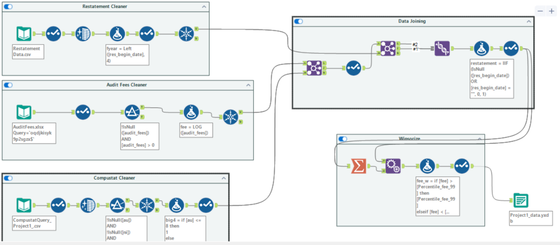
The Compustat, Audit Analytics Audit Fees, and Audit Analytics Restatement datasets were cleaned separately before being merged into a single analysis dataset. Observations with missing values in key variables were removed, and additional variables were created, including a Big 4 auditor indicator, log audit fees, log assets, leverage, return on assets, receivables, and inventory.
The datasets were then joined using company identifiers and fiscal year information. A restatement indicator variable was created, where observations associated with a financial statement restatement were assigned a value of 1 and all others were assigned a value of 0.
To reduce the influence of outliers, all continuous variables used in the analyses were winsorized at the 1st and 99th percentiles. Values above the 99th percentile were replaced with the 99th percentile value, while values below the 1st percentile were replaced with the 1st percentile value.
After the cleaning, transformation, and merging procedures were completed, the final dataset contained 54,921 firm-year observations.
Step 5: Linear Regression vs. Neural Network on Fees
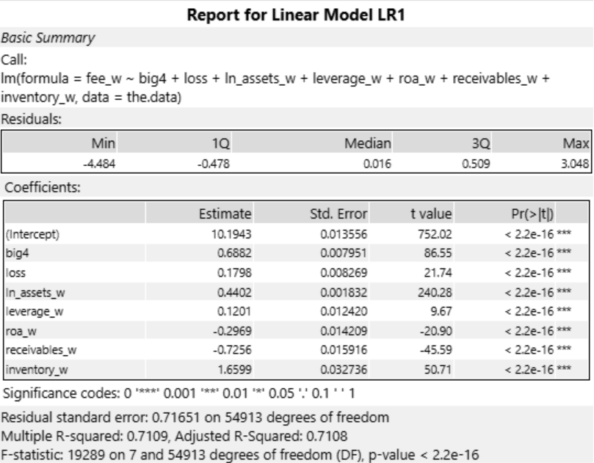
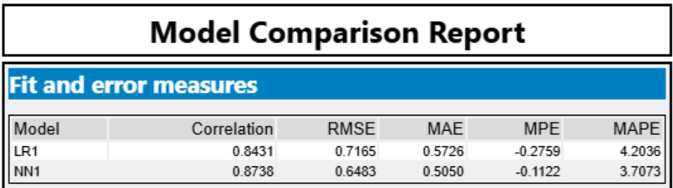
A linear regression model was used to examine the factors associated with audit fees. The results show that the Big 4 coefficient is 0.6882 and statistically significant (p < 0.001), indicating that companies audited by Big 4 firms pay higher audit fees than those audited by non-Big 4 firms, even after controlling for company characteristics.
The model explains approximately 71.1% of the variation in audit fees (R² = 0.7109), suggesting strong explanatory power. Firm size, leverage, and inventory were positively related to audit fees, while return on assets and receivables were negatively related to audit fees.
A neural network model was also developed and compared to the linear regression model. The neural network produced lower prediction errors across all reported metrics, including RMSE (0.6483 vs. 0.7165) and MAE (0.5050 vs. 0.5726), and achieved a higher correlation between predicted and actual audit fees (0.8738 vs. 0.8431). These results indicate that the neural network provided more accurate audit fee predictions than the linear regression model.
Step 6: Logistic Regression on Restatements
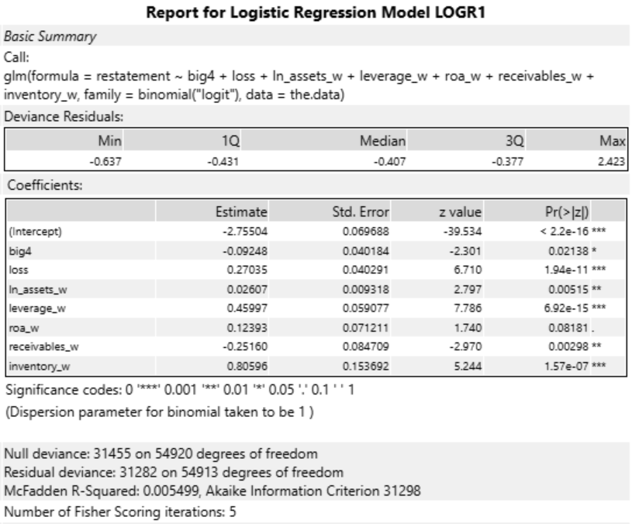
The coefficient on the Big 4 variable is -0.09248 and is statistically significant at the 5% level, with a p-value of 0.02. The corresponding odds ratio is approximately 0.912, meaning that firms audited by Big 4 auditors have about 9% lower odds of experiencing a restatement, holding all other variables constant.
These results support the expectation that Big 4 auditors provide higher-quality audits, as measured by a lower likelihood of financial statement restatements. Although the relationship is statistically significant, the economic benefit depends on the company's underlying restatement probability and the financial consequences of a restatement. We examine these costs and benefits further in Step 7.

Step 7: Cost-Benefit Analysis
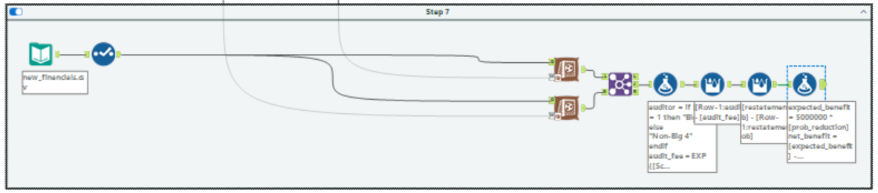
Restatement
Audit Fees
Based on the logistic regression, we find that the restatement probability is 9.12% if our company chooses a Big 4 auditor, and the restatement probability is 9.91% if our company chooses a non-Big 4 auditor. Thus, choosing a Big 4 auditor would reduce our company's predicted restatement probability by approximately 0.80 percentage points.
Based on the neural network model, we find that the predicted audit fee is $3,078,598 if our company chooses a Big 4 auditor, and the predicted audit fee is $1,394,402 if our company chooses a non-Big 4 auditor. Thus, choosing a Big 4 auditor would increase the predicted audit fee by approximately $1.68 million.

To determine whether hiring a Big 4 auditor is worthwhile, we compared the additional audit fee with the expected savings from avoiding a restatement. Hiring a Big 4 auditor would increase audit fees by approximately $1.68 million. However, assuming a restatement costs $5 million, the expected savings would be only $39,785 ($5,000,000 × 0.7957%). The additional audit fee is approximately 42 times the expected savings, resulting in a net cost of approximately $1.64 million. A Big 4 auditor would only break even if the cost of a restatement reached approximately $212 million. Based on these findings, we recommend hiring a non-Big 4 auditor.

Although our analysis favors a non-Big 4 auditor, it does not account for every potential benefit of hiring a Big 4 firm. Big 4 auditors may increase investor and lender confidence, improve access to financing, and strengthen the credibility of the company's financial statements. These benefits could be particularly valuable if the company plans to raise capital or go public.
Similar to how companies often hire a leading investment bank such as Goldman Sachs for major transactions, they may prefer established auditors despite their higher fees. Hiring a Big 4 auditor may reduce reputational risk for the audit committee by demonstrating that it selected a recognized and experienced firm, even if financial reporting issues arise. Additionally, the financial consequences of a restatement could exceed $5 million when considering litigation costs and reputational damage.
However, unless these additional benefits outweigh the approximately $1.75 million difference, hiring a non-Big 4 auditor remains the more cost-effective choice.

